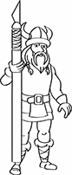 | NordicCon  Entry Sheet | 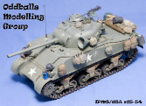
Name: | Chappie
Address: | 123 My Street  City, State 55987
Phone #: | 987-654-3210
Email: | chappie@internet.com
Club Memberships: | My Club, IPMS/USA, AMPS
Fill in Category and Model Description, and check Theme if entering. Registration will fill in Entry Numbers. Please return this sheet and entry forms to the Registration table. Thank you and enjoy the show!
 | Entry # | Category | Model Description | Theme
1 | -1 | B-5 | 1/72 P51-D Mustang – Tamiya OOB
2 | -2 | C-5 | 1/35 Panther
3 | -3 | F-3 | Ford F-150 SVT Raptor
4 | -4 |  | SAMPLE FORM
5 | -5
6 | -6
7 | -7
8 | -8
9 | -9
10 | -10
11 | -11
12 | -12
13 | -13
14 | -14
15 | -15
16 | -16
17 | -17

